Expense Manager

**MCA 6th Semester**

**MCSP-060 (Project Report)**

**Anirban Nandy**

**Enrollment No-105057536**

# Index

Contents

**MCA 6th Semester** 1

**MCSP-060 (Project Report)** 1

**Anirban Nandy** 1

**Enrollment No-105057536** 1

Index 2

Introduction: 4

**Figure:** Overview of Daily notebook & Social Networking Updater 5

Objective: 5

System Analysis 6

Identification of Need: 6

Preliminary Investigation: 6

Feasibility Study: 6

Project Planning & Scheduling: 6

Gantt chart 6

Tracking Gantt 7

Pert Chart 7

Software requirement specifications (SRS): 8

Functional Requirement 9

Non-functional Requirements 11

Software Engineering Paradigm applied 12

Data models 12

Context Diagram 12

0-Level DFD 13

1-Level DFD 14

2-Level DFD 15

Sequence diagrams 15

Entity Relationship Model, 18

Class Diagrams 19

Activity Diagrams 20

System Design 23

Modularisation details 23

DNBSN Engine: 23

DNBSN GUI: 23

DNBSN Storage: 23

Google Calendar: 23

Facebook/Twitter/LinkedIn API: 24

Data integrity and constraints 24

Entity integrity 24

Referential Integrity 24

Domain Integrity 24

User Defined Integrity 24

Database design 24

User Interface Design 28

Test Cases (Unit Test Cases and System Test Cases) 28

Coding 28

Complete Project Coding 28

Comments and Description of Coding segments 28

Standardization of the coding 28

Code Efficiency 28

Error handling 29

Parameters calling/passing 29

Validation checks 29

Testing 29

Testing techniques and Testing strategies used 29

Testing Plan used 29

Test reports for Unit Test Cases and System Test Cases 29

Debugging and Code improvement: 29

System Security measures: 29

Database/data security: 29

Creation of User profiles and access rights 29

Cost Estimation of the Project along with Cost Estimation Model 29

Reports (sample layouts should be placed) 30

Future scope and further enhancement of the Project 31

Bibliography 31

Appendices (if any) 31

Glossary. 31

# Introduction & Objective:

Expense Manager Software will let users track expenses and earnings. This software is basically developed for individual users so that they can track their daily expense, income and keep track of their money but this application will be useful to a company as well. Users can add daily earnings & expenses. It is to know how and where we are spending our money. It is the perfect system for individuals, families, and small business to manage their income and expense tracking. The friendly user interface makes it quick and easy to capture your income and expense transactions for each day. Expenses management software updates all our accounts daily so we'll always have access to the most current and accurate information about our finances and can clearly see how much money we have and owe, and where is your hard-earn money going.

At any point of time he can review his total expenses and generate report. There will be three different User Interfaces to allow the users use the software anywhere all the time. The User interfaces are Desktop Interface, Mobile Interface & Web Interface. The data from all the interfaces can be synced and merged to generate a final report.

The Desktop Interface is the main & fully featured version of the software. Users can add new data, browse old expenses and sync expenses from Mobile & Web Interfaces. The Mobile Interface will allow users to add data using their mobile and use customized feature set. While shopping people carry their mobile along with them and then they can add expenses and earnings instantly to avoid forgetting about certain expenses. The Web Interfaces provide the ultimate flexibility of login to the user accounts in the web and add/browse expenditures.

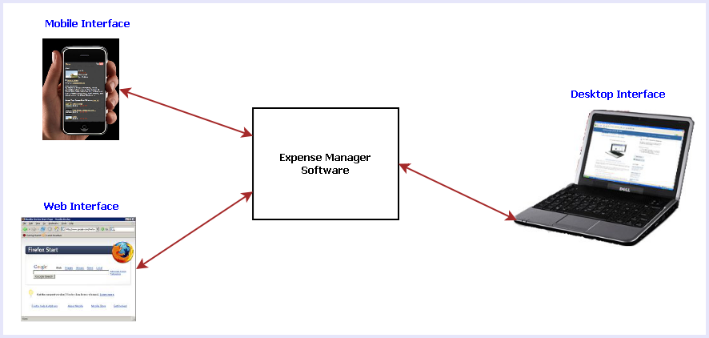

Fig 1: Different interfaces of Expense Manager Software

The main features of this software are listed below:

1. Calendar view to select any date and add/view the expenses & earnings.
2. Add tag with expenses so that user can remember the reason for spending
3. View Available balance
4. View Total expenses
5. Create a contact book for add contact of the person.
6. Generate weekly, monthly and yearly Expenses report Income report Profit and Loss report.
7. Online sync
8. Reminder facility for future expenses.
9. Searching the expenses.
10. On the go expense tracking using Mobile & Web Interfaces
11. Syncing data from all the interfaces such as: Desktop, Mobile & Web.

# System Analysis

## Identification of Need:

Nowadays people are so busy and technology dependants that they don’t even bother to remember their own phone number. And off course, I am one of those persons. One of the problems I have been facing since my childhood is that I really do not like to write down how much money did I spend in an entire day or in the entire month. Eventually I forget all those details. I used to struggle to provide exact details of my expenses to my parents. The problem has increased when I started earning. It can be easily understood that things really got more complicated and I also know that things are going to get worse when my income source and expense fields would increase. So I strongly felt the necessity of an application or software that would allow me to keep track all the details of my income and expenses easily and efficiently. I believe expense manager is a perfect application for that.

## Preliminary Investigation:

When I myself faced this problem and felt the need of an application, I started discussing about the problem and to my surprise, I found out that almost all of them are facing similar problems. Actually we nowadays are so technology dependant that we expect that all our tasks would be done by our computer or our mobile devices. So I noted down all the problems and their probable solution on a notepad and started consulting with some of my seniors who are IT professionals as well. After gathering all the information I felt this could be a really fruitful project.

## Feasibility Study:

It is an admitted fact that people are becoming more and more addicted to social networking sites day by day. People would love an application that would make their social networking experience more interesting and flawless. I have decided to provide a password manager that to keep track of the id and passwords created in various websites on the internet. So, undoubtedly it is going to be a popular web cum desktop application.

## Project Planning & Scheduling:

### Gantt chart

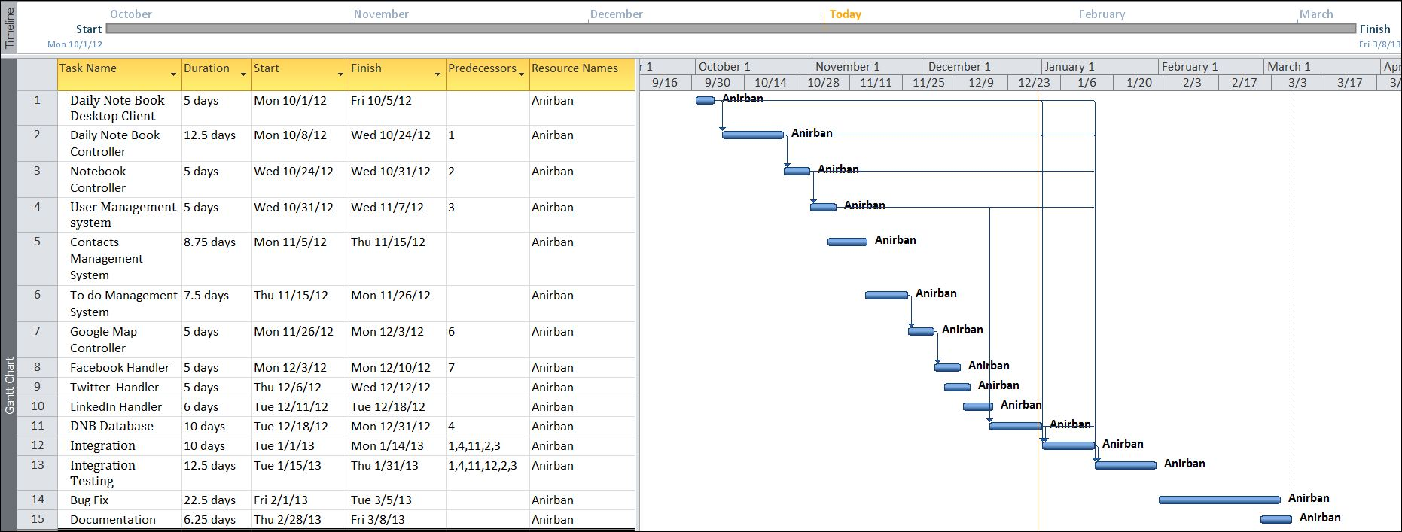

### Tracking Gantt

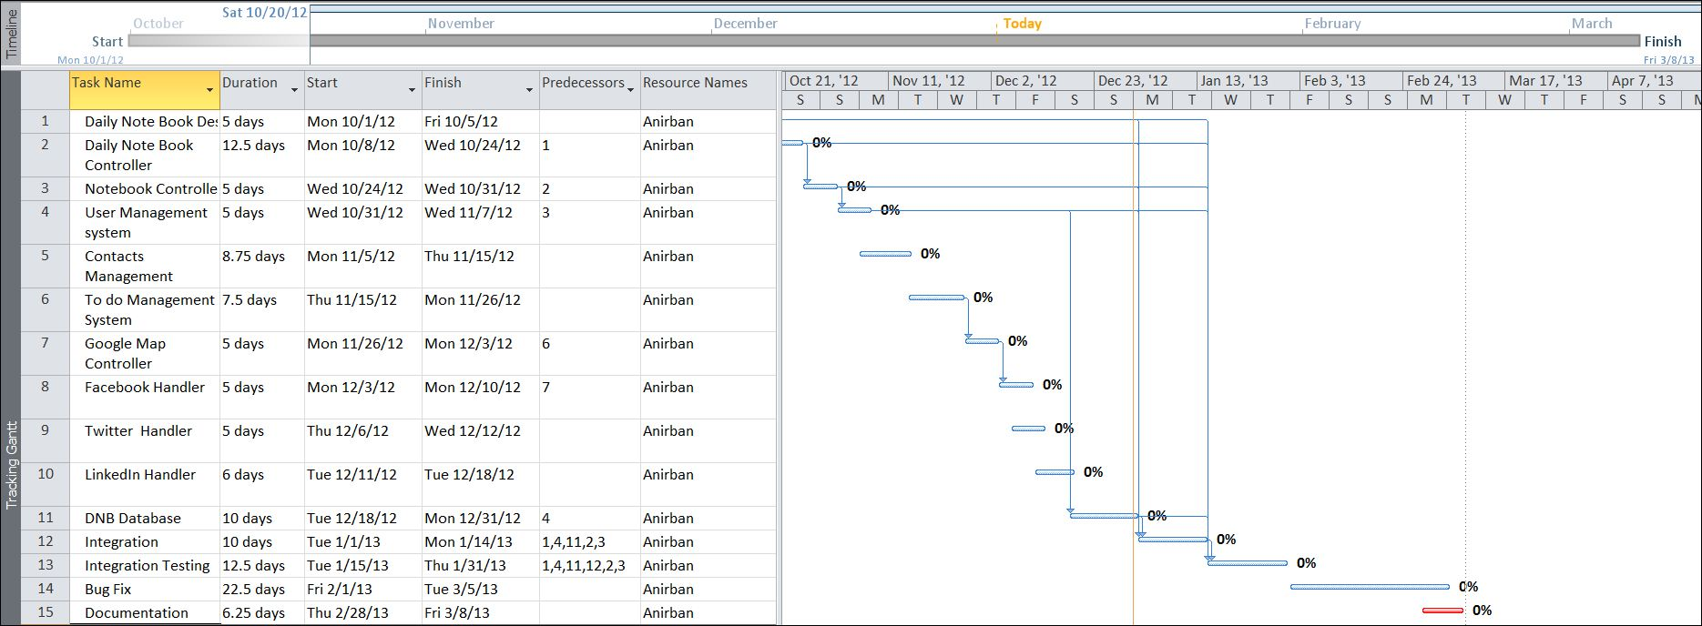

### Pert Chart

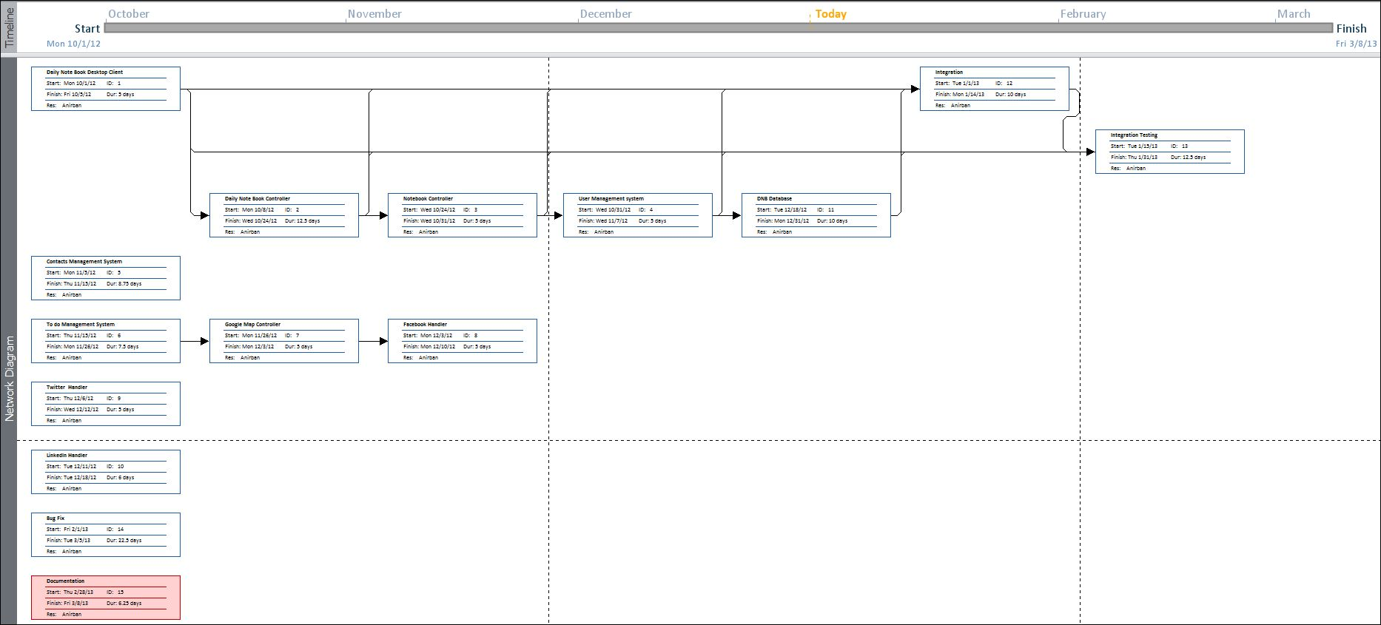

## Software requirement specifications (SRS):

### Functional Requirement

#### Register User

**Introduction:**

Register a new User.

**Input:**

Relevant User data like name, user id, password, hints etc.

**Processing:**

The **DNBSN** willcreate a new user entry.

**Output:**

The **DNBSN** will generate a user to use the application.

#### Login User

**Introduction:**

Logging in as an existing User.

**Input:**

User will provide user id, password.

**Processing:**

The **DNBSN** willcheck the authorization of the particular user.

**Output:**

The **DNBSN** will allow accessing feature to the user if the given data match with the internal information, otherwise denying user.

#### Update Note or Event

**Introduction:**

User can add note or event.

**Input:**

User will compose note or event for update to note book or social site. And select the option where he wishes to update the event.

**Processing:**

The **DNBSN** willcreate a new event for note book and share the event to the selected social site.

**Output:**

The **DNBSN** will save event in note book and share it in social site.

#### Load Google Map

**Introduction:**

User can load Google map through **DNBSN**.

**Input:**

Current location.

**Processing:**

The **DNBSN** willget location from google map.

**Output:**

The **DNBSN** will display the particular location.

#### Share event in Google calendar

**Introduction:**

User can share event in google calendar through **DNBSN**.

**Input:**

The user selects the event from note book to upload in google calendar.

**Processing:**

The **DNBSN** will upload event in calendar.

**Output:**

The google calendar will display the particular event.

#### Search Event

**Introduction:**

User can search event.

**Input:**

He will enter data like key word or date etc.

**Processing:**

The **DNBSN** will search for the requirement.

**Output:**

The **DNBSN** will display the search result.

#### Add Contact

**Introduction:**

The **DNBSN** will Store a new Contact.

**Input:**

Relevant contact data like name, e-mail id, mobile no, fax no. address, blood group etc.

**Processing:**

Admin will enter the data in the **DNBSN** and create a new Donor entry.

**Output:**

The **DNBSN** will generate a contact detail for future reference.

#### Add To Do

**Introduction:**

The **DNBSN** will Store a new task in To Do.

**Input:**

Relevant task data like task detail, priority etc.

**Processing:**

Admin will enter the data in the **DNBSN** and create a new task entry.

**Output:**

The **DNBSN** will generate a task detail.

### Non-functional Requirements

* The application will be **self-dependent** and no dependency on other parties required.
* There will be a digital **backup** and restore system.
* There will be more **opportunity** to extend the application in various type of device in future.
* The response time will be low and the system will **response** fast.
* It will be very **user friendly** and **usable** by any person with minimal computer knowledge.
* In terms of **security** unauthorized access will be denied and register user will be able to change as necessary.
* It will be **efficient** as it reduces manual labor and searching.
* **DNBSN** will have user manual and help **documents**.
* It is designed such a way that it can be **maintained** with minimal effort.

## Software Engineering Paradigm applied

## Data models

### Context Diagram

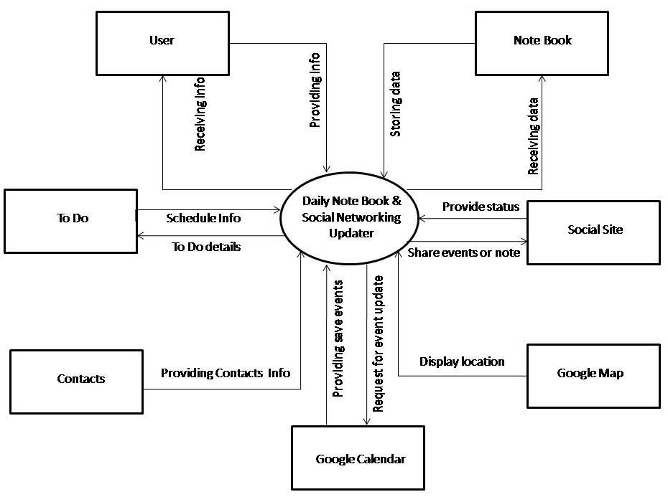

### 0-Level DFD

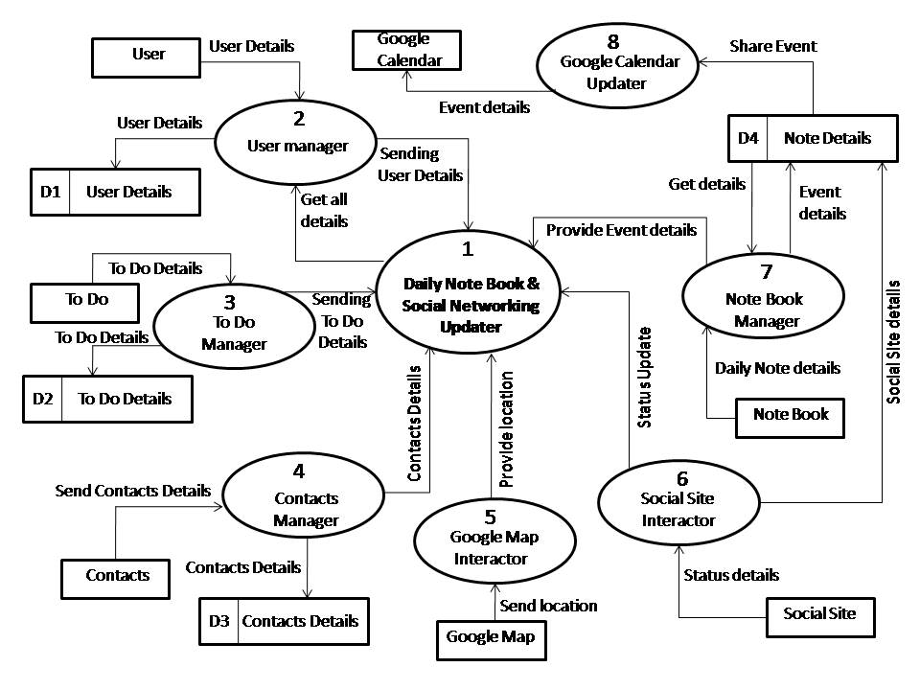

### 1-Level DFD

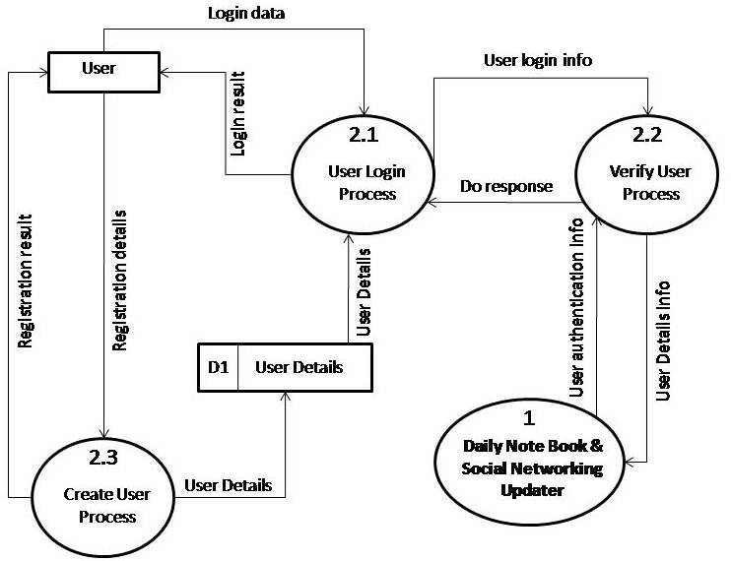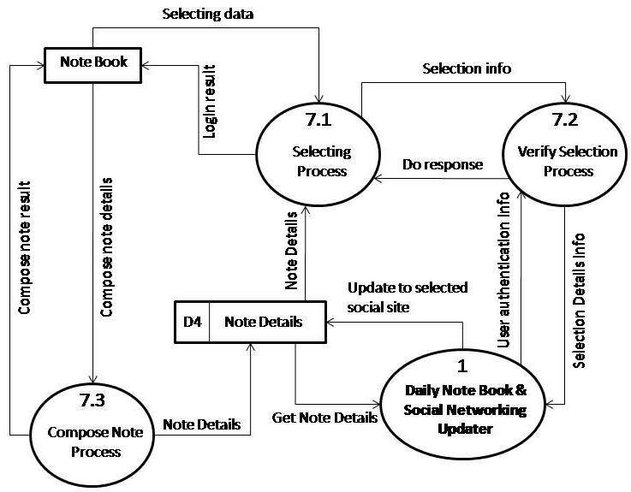

### 2-Level DFD

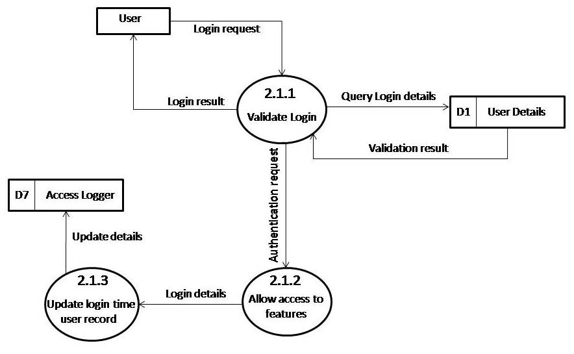

## Sequence diagrams

**Interaction Event**

**: Login**

**User**

**: Register**

**User**

**Controller**

**: Update**

**Event**

**: Events**

**Report**

**: View**

**Update Event**

**Report**

**register**

**register**

**modifyEvent**

**addEvent**

**deleteEvent**

**showError**

**showError**

**ShowError**

**updateEvent**

**updateEventReport**

**updateEventsReport**

**showError**

**showError**

**showError**

**viewReport**

**viewEventReport**

**displayEventReport**

**displayReport**

**Share Event in Social Site**

**register**

**register**

**updateEvent**

**syncNotComplete**

**syncComplete**

**syncEvent**

**syncEvent**

**displayEvent**

**syncComplete**

**: Login**

**User**

**: Register**

**User**

**Controller**

**: Update**

**Desktop**

**Event**

**: Update**

**Web**

**Application**

**:Update**

**Desktop**

**Application**

## Entity Relationship Model,

We will design a RDBMS for Daily notebook & Social Networking Updater. The entities and their attributes are listed below. Attributes in Bold letter is the unique key.

|  |  |
| --- | --- |
| **Entities** | **Attributes** |
| Note | **Note Id**, Content, Time, Size, Web Service id, user |
| RSS Feed | **RSS Feed Id** , Web Service Id, Content, time, size |
| Daily notebook & Social Networking Updater | **Sw Id**, Web Services Supported, Users, Size |
| User | **User Id**, Name, Social Network Data, Preferences. |
| Web Service | **Web Service Id,** Authentication Data, Feed Data, Preferences. |

**Relationship between Entities:**

* Daily notebook & Social Networking Updater has User 🡪 1 : N
* Users post Notes 🡪 1 : N
* Web Service generates Feeds 🡪 M : N

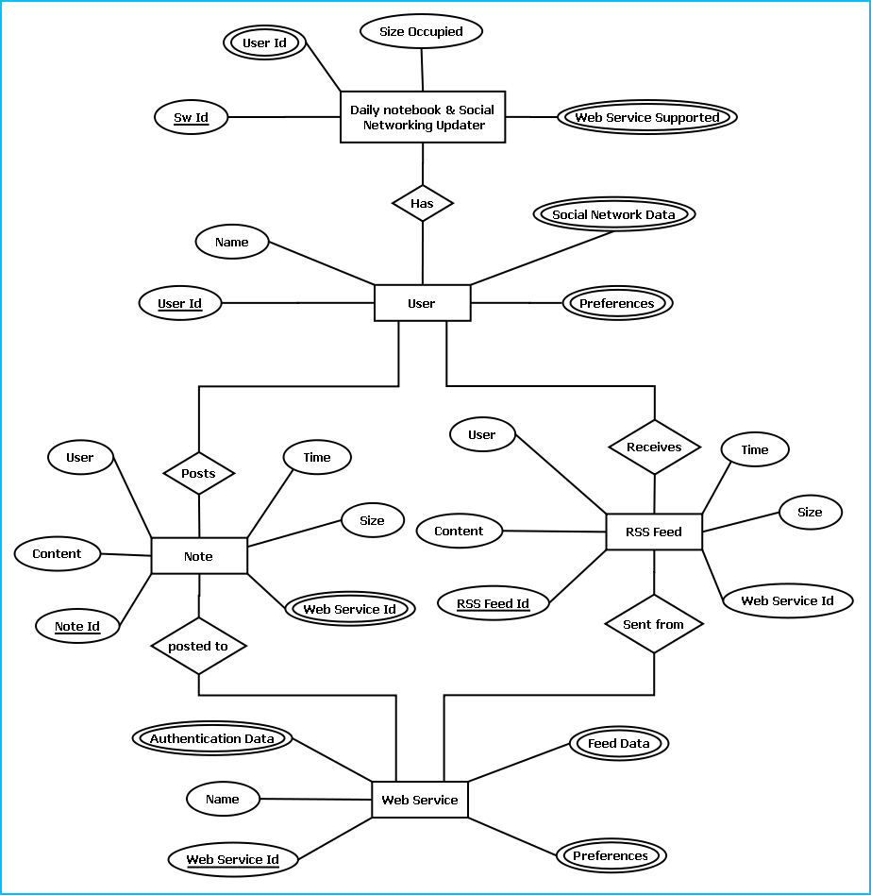

E-R Diagram of Daily notebook & Social Networking Updater

## Class Diagrams

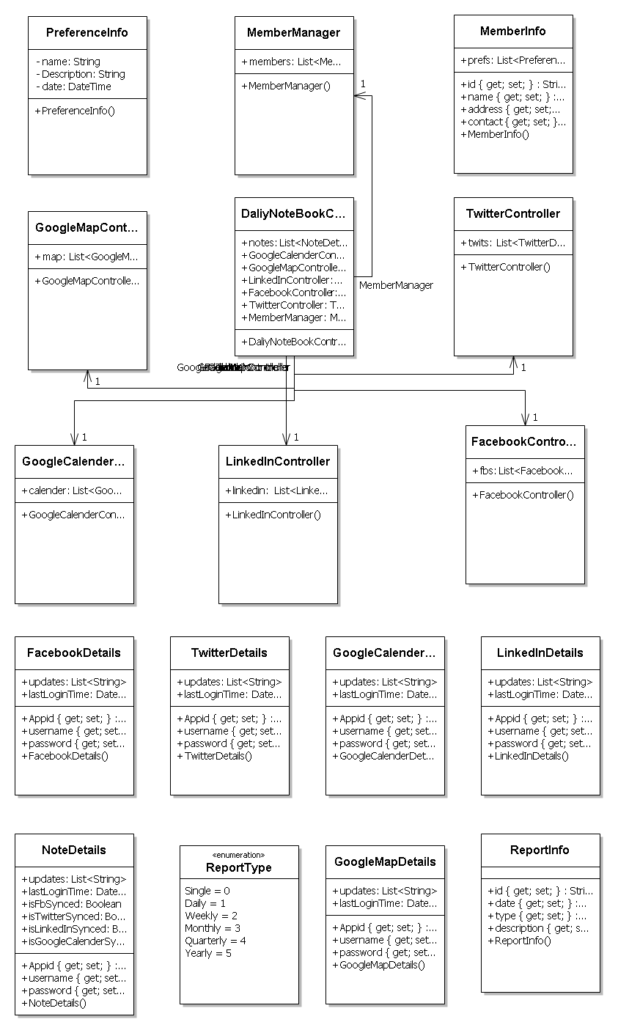

## Activity Diagrams

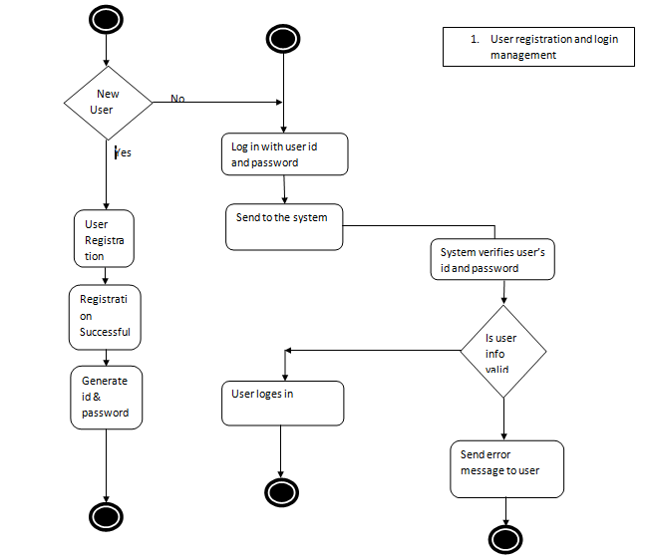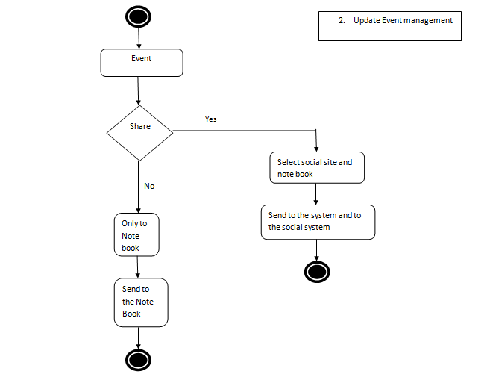

# System Design

## Modularisation details

### DNBSN Engine:

This module handles all the logical parts of DNBSN. It takes data from user through DNBSN GUI module and stores them to database using DNBSN Storage module. It sends the data to the user’s social networking account using corresponding site’s API. The data stored is taken from the DNBSN Storage and sent to the API. It saves the events details in the Google calendar.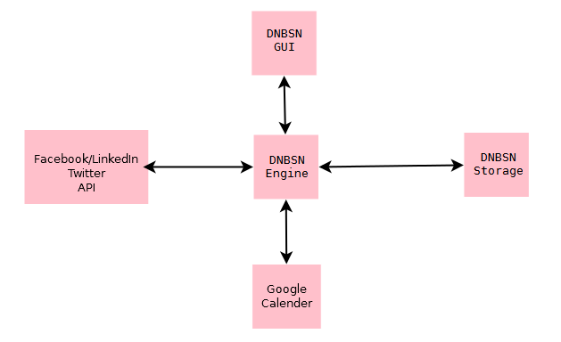

### DNBSN GUI:

This part is the place through which user interacts. This module contains all the designs which are visible and intractable by users. User provides input through it and gets the output through it. It is generally created by various tools like buttons and listviews.

### DNBSN Storage:

In this module all the data are stored. DNBSN Engine stores data in this module and fetches them for output through this module.

### Google Calendar:

This place gets input from the DNBSN engine. All the relevant data sent by user to Google calendar is stored here which could be accessed by user globally.

### Facebook/Twitter/LinkedIn API:

These modules provide news feed to user using the DNBSN engine through DNBSN GUI. It further gets the input, i.e. status update to the user’s account.

## Data integrity and constraints

We have used Integrity constraints in **DNBSN** to ensure accuracy and consistency of data in a relational database. Data integrity is handled in a relational database through the concept of referential integrity. There are many types of integrity constraints in **DNBSN** that play a role in referential integrity.

Codd initially defined two sets of constraints but, in his second version of the relational model, he came up with four integrity constraints:

### Entity integrity

In **DNBSN** we used various type of primary key and consciously we set the primary key property as not null. The entity integrity constraint states that no primary key value can be null. This is because the primary key value is used to identify individual tuples in a relation. Having null value for the primary key implies that we cannot identify some tuples. This also specifies that there may not be any duplicate entries in primary key column key row.

### Referential Integrity

The referential integrity constraint is specified between two relations and is used to maintain the consistency among tuples in the two relations. Informally, the referential integrity constraint states that a tuple in one relation that refers to another relation must refer to an existing tuple in that relation. It is a rule that maintains consistency among the rows of the two relations.

### Domain Integrity

**DNBSN** has various type of data field with set by default value of Null because if the value is not provided by the user, the vale will be set as null. The domain integrity states that every element from a relation should respect the type and restrictions of its corresponding attribute. A type can have a variable length which needs to be respected. Restrictions could be the range of values that the element can have, the default value if none is provided, and if the element can be NULL.

### User Defined Integrity

A business rule is a statement that defines or constrains some aspect of the business. It is intended to assert business structure or to control or influence the behaviour of the business.

## Database design

The database used for this software is called **Dnbdb**. Database tables and corresponding keys are shown in tabular form. It shows the tables and its columns. A key in **Bold** is the primary key.

Screenshots of table structures:

Table: user

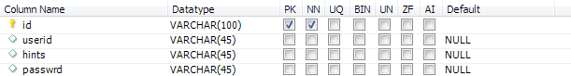

Table: contact

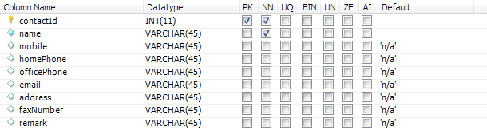

Table: Note

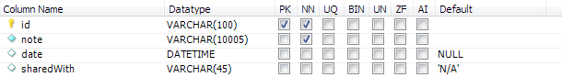

Table: password

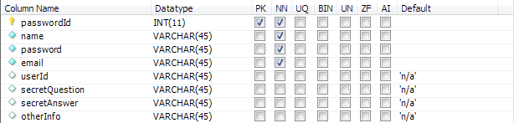

Table: tasks

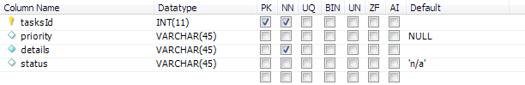

|  |  |
| --- | --- |
| **Tables** | **Keys** |
| Note | **Note Id**, Content, Time, Size, Web Service id, user |
| RSS Feed | **RSS Feed Id** , Web Service Id, Content, time, size |
| Daily notebook & Social Networking Updater | **Sw Id**, Web Services Supported, Users, Size |
| User | **User Id**, Name, Social Network Data, Preferences. |
| Web Service | **Web Service Id,** Authentication Data, Feed Data, Preferences. |

## User Interface Design

Screen shot

## Test Cases (Unit Test Cases and System Test Cases)

# Coding

## Complete Project Coding

Code

## Comments and Description of Coding segments

Various types of comments and description we use in our coding section. Some of them are:

//open the connection

This comment is use at the data interaction section where the code to open the MySql connection.

//define the command reference

To define a command reference in MySql.

//define the connection used by the command object

To define the connection, which is used by the comment object.

//always close the connection

It is indicating to close connection after code is executed.

Manu Unused code in our project we did comment them also like :  
<!--<Condition Property="Password" Value="c" />-->

## Standardization of the coding

12

## Code Efficiency

We started working on the project keeping in mind that we must develop it in a way that it not only provides a very easy to use GUI but also provide a fast and flexible service to the users. We know that a particular work can be done in more than one ways. We have tried all the options and then chose the one which provides the fastest and most secure performance. First of all, we have used the latest technologies of Microsoft like visual studio 2010 as IDE and WPF as GUI to keep our application’s performance few steps ahead. We have studies all the rules of software development life cycle and applied them to keep our application flexible. We have given special attention to the storage related codes. We have avoided all the unnecessary database codes and kept them as short as possible without harming our purpose so that insertion, updating, deletion and fetching of data take place flexibly. You can see the result as a user; our application does all the works very smoothly.

## Error handling

## Parameters calling/passing

## Validation checks

# Testing

## Testing techniques and Testing strategies used

## Testing Plan used

## Test reports for Unit Test Cases and System Test Cases

## Debugging and Code improvement:

# System Security measures:

## Database/data security:

It encrypts the data stored in the database so that even if someone succeeds to hack the database still not much harm could be done.

The application will use Google open-id authentication for web interface.

## Creation of User profiles and access rights

The software requires a predefined username and password to login.

It allows a guest login as well which lets a guest user user this application with very limited access to the user data.

# Cost Estimation of the Project along with Cost Estimation Model

We used the basic COCOMO model, which gives an approximate estimate of our **DNBSN** project parameters. The basic COCOMO estimation model is given by the following expressions:

Effort = a1 * (KLOC)a2 PM

Tdev = b1 * (Effort)b2 months

Where

KLOC is the estimated size of the software product expressed in Kilo Lines of Code a1, a2, b1, b2 are constants for each category of software products.

Tdev is the estimated time to develop the software, expressed in months.

Effort is the total effort required to develop the software product, expressed in person-month (PM).

Our project is semidetached type, because the development team consists of a mixture of experienced and inexperienced staff like my guide and me. Team members may have limited experience on related system but may be unfamiliar with aspects of the system being developed.

## Estimation of development effort

For our Semi-detached class software product **DNBSN**, the formula for estimating the effort based on the code size is shown below:

Semi-detached **DNBSN**: Tdev = 3.0*(KLOC)1.12 PM

## Estimation of development time

For our Semi-detached class software product **DNBSN**, the formula for estimating the development time based on the effort is given below:

Semi-detached DNBSN: Tdev = 2.5*(Effort)0.35 months

Assume that the size of a Semi-detached **DNBSN** product has been estimated to be 3,200 lines of source code. Assume that the average salary of software engineer(me) is Rs. 20,000 per month.

Assume that the size of our

The basic COCOMO estimation formula for DNBSN semidetached software:

Our Effort = 3.0 * (3.2)1.12 PM

= 11 PM

Normal Development time = 2.5 * (11)0.35 months

= 6 months

Cost required to develop the product = Rs. 6 * 20000

= Rs. 120,000

# Reports (sample layouts should be placed)

* List of Facebook updates could be generated.
* List of twitter update could be generated.
* A list of events could be generated.
* List of LinkedIn update could be generated.
* List of google plus update could be generated.

# Future scope and further enhancement of the Project

* Now it will display the text based RSS feeds and link of the multimedia contents. We will display the Multimedia contents like Video, Audio & Image in future.
* To support UNIX / Linux Based Operating systems.
* To Support Mobile Operating systems for Symbian, Meego & Android.

# Bibliography

* <http://en.wikipedia.org>
* <http://msdn.microsoft.com/en-us/>
* <http://www.microsoft.com/en-us/default.aspx>
* <http://www.codeplex.com/>
* <http://stackoverflow.com/>
* <http://www.codeguru.com/>
* <http://www.w3schools.com>
* <http://blogs.technicise.com/>
* [www.mysql.org](http://www.mysql.org)

# Appendices (if any)

# Glossary.